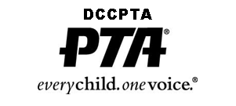
P&P Luncheon Slide Show Submissions Form
Duval County Council PTA

Richard Godke, rgodke@yahoo.com, 904/693-3501
01-19-16
Please email this form and 3-4 photos from your PTA programs, from the past year, to mailto: rgodke@yahoo.com by April 16. These photos will be used at the DCCPTA P&P Luncheon that will be held in May. This special slideshow will showcase each PTA's successes and hard work. If you email will not allow multiple files, please send on separate emails. If you would like to become a better PTA photographer click this link for 5 simple pointers Photo Communication Tips: PTA

PTA or PTSA Name: Click here to enter text. Contact Person: Click here to enter text.
Contact Phone: Click here to enter text. Contact email: Click here to enter text.
____________________________________________________________________
Photo #1
Photo file name: Click here to enter text.
Photo description: Click here to enter text.
Photo #2
Photo file name: Click here to enter text.
Photo description: Click here to enter text.
Photo #3
Photo file name: Click here to enter text.
Photo description: Click here to enter text.
Photo #4
Photo file name: Click here to enter text.
Photo description: Click here to enter text.

