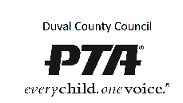
Understand the Conflict - Worksheet
Richard Godke - rgodke@yahoo.com - DCCPTA Leadership Training June 16, 2016

It is important for you to define clearly your position and interests in the conflict, and to understand those of your opponent. Use this worksheet to help generate ideas to help neutralize the conflicts before a face to face meeting.
What is the conflict?

 |  | Self | Others
Interests?

Sticking point in conflict?

Want?

Need?

Concerns, hopes, fears?

Influencing Points

