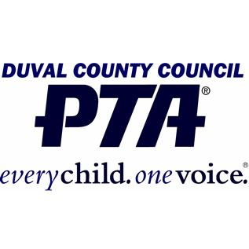
Presidents’ and Principals’ Luncheon
Performance Application
- Your group must be available to perform on Tuesday May 16th, 2017 to apply
- Electronic Submissions only, due April 3rd, 2017 by email to Paige Santa Lucia at PandP@dccpta.org
- All submissions must include a video of your performance
- Performances must be 3-5 minutes long
- Your school’s PTA must be in good standing in order to be eligible

School Name: Enter School Name
Name of Group: Enter Group’s Name
Number of Students: Enter # of Students
Brief Description of Performance: Enter Performance Description
Technical Needs: Enter Technical Needs
Group Sponsor’s Name: Enter Sponsor’s Name
Sponsor’s Contact Number: Enter Sponsor’s Phone #
Principal’s Name: Enter Principal’s Name
Email: Enter Principal’s Email

Due April 3rd, 2017 - Electronic Submissions Only With Video
Please email to Paige Santa Lucia at PandP@dccpta.org

